**MÓDULO 5 – MIC014 – AULA 08**

**Alunos: Wesley Silva Araújo e Lucas Gabriel Rocha Constancio**

**DATA: 21/12/2024**

**Repositório GitHub:**

**Link:** <https://github.com/lucasrocha777/HandsON-Maloca-das-iCoisas---IOT>

**Organograma:**

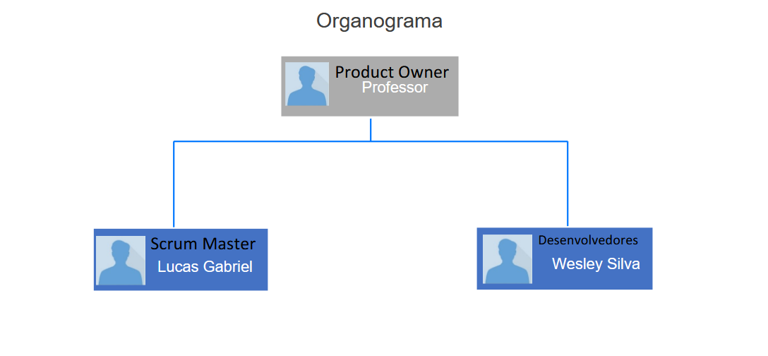

**Circuito:**

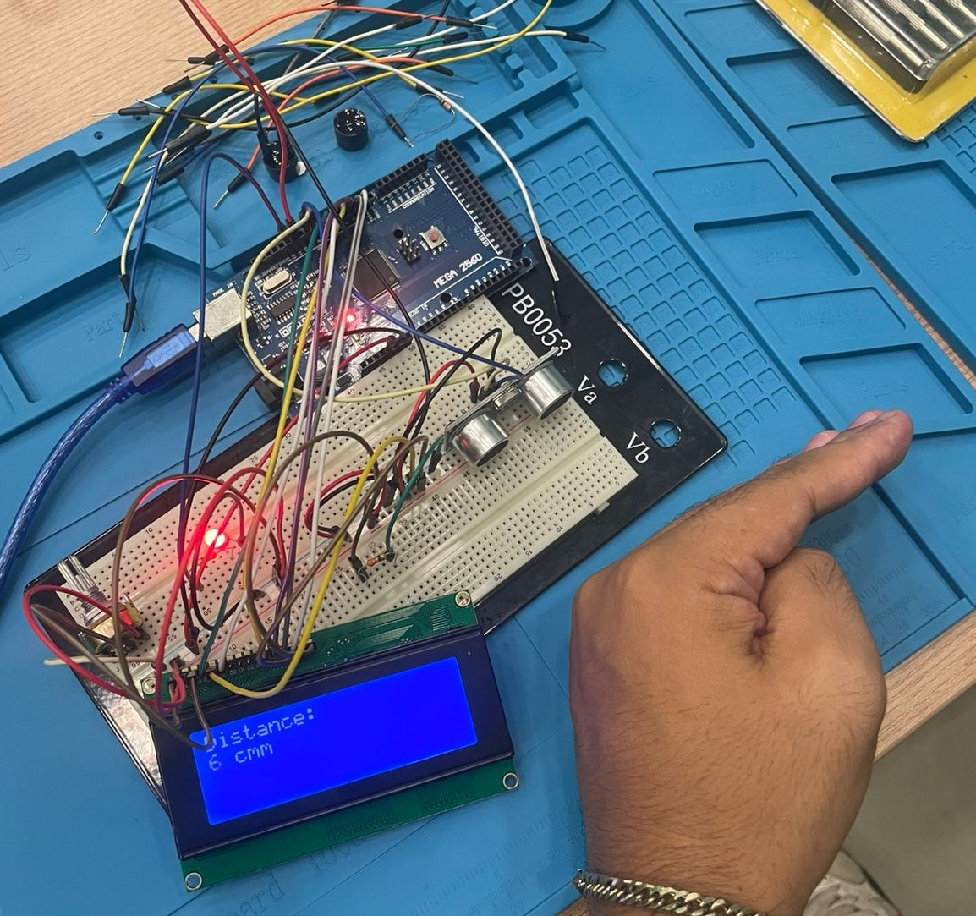

**Trello:**

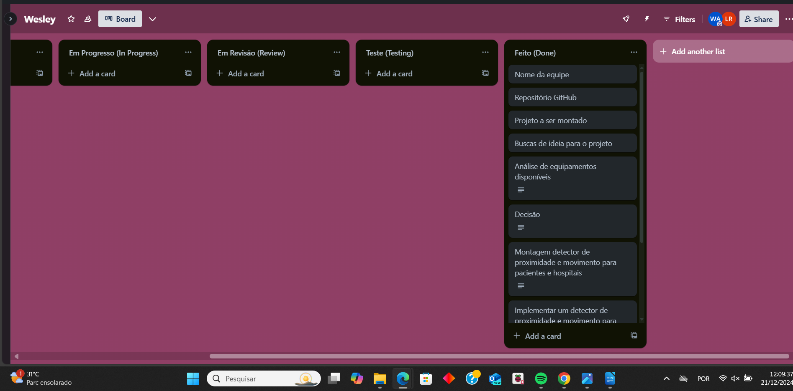Link: <https://trello.com/invite/b/66760ba6cc15ba637d555907/ATTI3c11075f1d955710d36f4ab4a3d9602173C9D877/wesley>